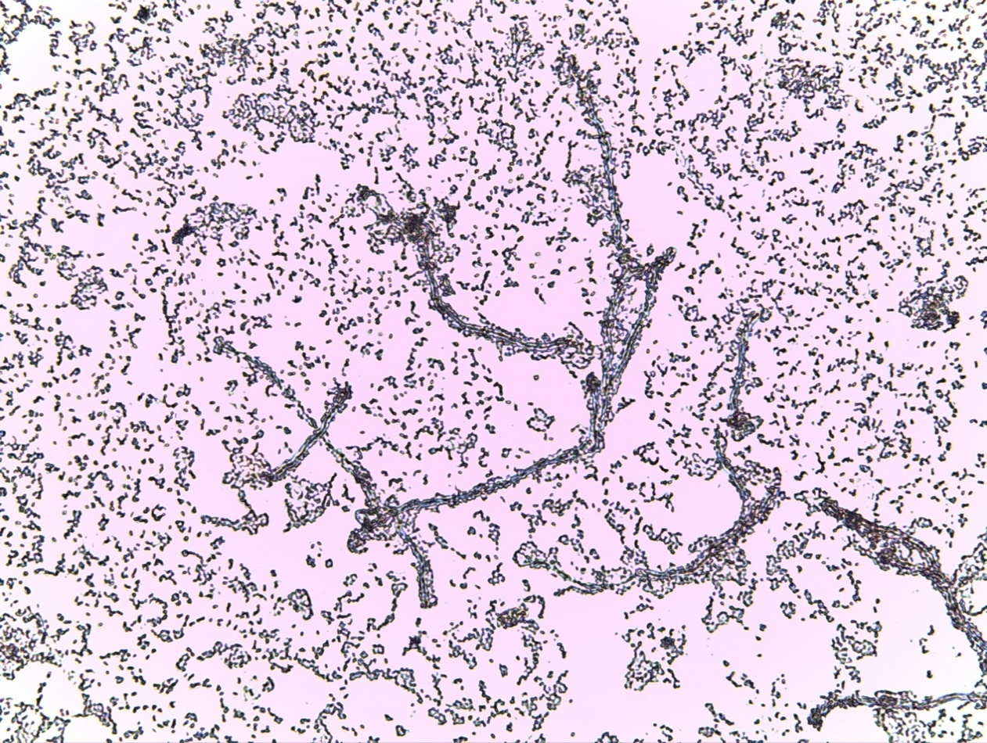Cultivating PHBV degrading bacteria and measuring PHBV degradation on a flow cytometer

Created by: Micha Snippe

Student ID: 385653

Class: BOVT3

Date: 01-04-2021

Teacher: Dr. Jeroen Siebrink

# Abstract

In our daily life we use a lot of long-lasting plastic. In an attempt to negate these negative effects of these plastics the world is slowly shifting to the use of bioplastics. These plastics are polymers produced by microorganisms to store energy, this has as effect that they are easier to break down. One of these bioplastics is Poly(3-hydroxybutyrate-co-3-hydroxyvalerate) also known as PHBV and will be the focus of this experiment.

The goal of this experiment is to cultivate PHBV degrading microorganisms and measure the PHBV degradation using a flow cytometer. Basal mineral medium supplemented with PHBV was used in order to cultivate the microorganisms in Erlenmeyer flasks. To determine the if the growth was due to PHBV degradation for this agar plates were made were half was coffered with PHBV. Finding that the microorganisms were only able to grow on the PHBV side.

Several preparation methods were used for measuring plastic on the flow cytometer. One of these methods was the staining of the plastic with oil red o to give a better separation from the microorganisms. This had as effect that the emission of the plastic in most fluorescence channels rose. A large problem in analyzing plastic on the flow cytometer is identifying and isolating only the plastic particles. For this the freeze thaw was used, this method destroys microbial cells leaving only plastic inside the solution. This had the intended result on the flow cytometer data removing/reducing the area which was suspected as being microbial.

We created a large amount of comparison plots plotting different columns against each other. This resulted in a plot where fluorescence 1 was plotted against Width, showing two different hotspots indicating different populations. A near perfect separation of plastic and microbes was found when these areas were gated out with it being consistent over multiple samples.

Even though we were not able to directly measure the PHBV degradation using the flow cytometer, we were able to isolate the plastic from raw data. This is by itself not that significant but shows you can measure plastic using a flow cytometer, and with further research it should be possible to determine the amount of degradation using our technique.

# Abbreviations

Poly(3-hydroxybutyrate-co-3-hydroxyvalerate) = PHBV

Flow cytometer = FACS

Freeze thaw method = FT

Forward scatter = FSC

Sideward scatter = SSC

Index

Abstract 2

Abbreviations 3

Introduction 5

Material & Methods 7

Grow Medium 7

Growing the microorganisms 7

Determining growth 7

Determining PHBV degradation from bacteria 7

Staining the PHBV 7

Destroying cells using freeze thaw 8

Measuring PHBV on the flow cytometer 8

Statistics 8

Results 9

Determining growth 9

Determining PHBV degradation from bacteria 9

Effects of freeze thaw on sample 10

Finding PHBV in flow cytometry 11

The effect of staining the PHBV 13

Conclusion and Discussion 14

Reference 15

Appendix 16

# Introduction

In our daily life we use a lot of plastics. Most of these plastics are single use after which they fill up landfills and pollute the environment for years or even centuries. In an attempt to negate these negative effects of these plastics the world is slowly shifting to the use of bio-plastics.

These plastics are polymers produced by microorganisms to store energy, which means that these microorganisms don’t only build but also break down these plastics. This shift to bio-plastics means that the growth of plastic pollution will be lessened because of the degradation of these plastics.

One of these bioplastics is Poly(3-hydroxybutyrate-co-3-hydroxyvalerate) (PHBV) this polymer consist of 2 different monomers. The first monomer is hydroxybutyrate and the second is hydroxyvalerate (figure 1). PHBV can have different chemical and physical properties based on the ratio between these monomers, making it useful in many different applications from packaging to biomedical applications [1]. When this molecule is degraded only water and carbon dioxide will be formed and has a low cytotoxicity. These characteristics make it suitable for use in medical applications. One of the ways PHBV is degraded is by means of micro-organisms as some use it as energy storage just like animals use vat. Ibrahim, M. I. et al, found that PHBV loses 1-4% of it molecular weight after 90 days in water [2].

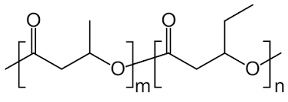

Figure 1 The chemical stucture of PHBV. The first monomer m is the hydroxybutyrate and the second monomer n is the hydroxyvalerate. The m and n are stand-ins for how much the PHBV contains those monomers.

To measure the PHBV a flow cytometer (FACS) was used. This technique is used to measure surface characteristics and the fluorescence of a cell. This is done by congesting the cells in a sample enough so that only one cell is measured at a time. The measurement is done using a laser that shines on a cell, the scatter light is then measured using sensors. The light that scatters forward or forward scatter (FSC) gives insight in how large the cell is. While the light that scatters sideward of sideward scatter (SSC) gives insight in how complex the surface is of the cell. The FACS also measures the fluorescence emissions on 4 different wavelengths. The use of fluorescence is mostly used in for the identification of cells by dyeing them with fluorescence dyes. With the use of this technique, we hope to identify the plastic based on their fluorescence properties and see a difference in forward and sideward scatter before and after degradation.

Some of the samples are dyed with Oil red O this is to enhance the amount of fluorescence emission measured on the FACS. Oil red O is an organic compound known as a lysochrome meaning that is a fat soluble dye and is therefore usually used for staining lipids and triglycerides. One of the properties of this dye is that it is fluorescent with a large emission spectrum of 576 to 750 nm [3]. This makes it useful for measurement in the FACS as it covers three of the four fluorescence frequencies used (533, 585, 670, 765 nm).

The freeze thaw method is used to make sure we only measure plastic using the FACS. This method is used to destroy cells present in the samples. This is done by freezing and thawing the samples multiple times. This causes the cells to swell and break in ice crystals when frozen and contract while thawing. This is done multiple times to destroy most if not all of the cells. We hope that using this method would make it eliminate or limit the interference of cells when measured using the FACS.

The increasing use of bioplastics has helped to lessen the total growth of long lasting plastic in the environment. However wider adoption of bioplastics will only help the environment when there is a more active degradation process available to stop the plastic accumulation. With this project we want to find microorganisms or cultures that can breakdown these bio-plastics to products possibly useful in other industries, and increasing the incentive to start actively breaking down these plastics.

# Material & Methods

## Grow Medium

In order to grow micro-organisms basal mineral medium was used. It consists of magnesium sulfate (0.20 g/L), calcium chloride (0.25 g/L), potassium phosphate (1.04 g/L), dipotassium phosphate (1.0 g/L), ammonia nitrate (1.04 g/L) and iron(III)chlorate (0.065 g/L) with an addition of 10 g/L PHBV as the soul carbon source. When appropriate 1.5% agar (granulated agar, BBL) was added. The culture 5LLM1 was kindly provided by dr. J. Siebring. This culture was isolated because of its ability to degrade PHA polymers.

## Growing the microorganisms

To grow the culture, Erlenmeyer flasks were used, each containing around 20 ml basal mineral medium. These Erlenmeyer’s were than incubated with about 1 ml of the culture 5LLM1 or derivatives. Because the goal of this experiment was to find micro-organisms that can degrade PHBV none of the materials were used for growing the culture in the flask where sterilized.

## Determining growth

To determine that there was growth taking place in the medium as a result of PHBV depredation, plates were created by adding 1,5% agar to the recipe of the basal mineral medium as a solidifying agent. The plates were poured in two layers: the first layer was the base and only consist of the basal medium without the plastic, and the second layer was a thin layer containing the plastic. This was done to only have plastic at the place where it was needed. These plates where then inoculated with 200 microliters of culture. Each of these plates where then incubated by 37 °C for a couple of days. After the incubation period the amount of growth was determined by counting the amount of cell on a Bürker-Türk, and a Gram staining was performed.

## Determining PHBV degradation from bacteria

Plates were made where half of the plate was covered in PHBV. These plates were then inoculated with 50 microliters of culture and spread out over the entire plate, after which they were incubated by 37 °C.

After incubation the plates were inspected to see if the bacteria were only growing on the side of PHBV indicating that the bacteria uses the PHBV as a food source or over the entire plate indicating it can also use CO2 as source of carbon.

## Staining the PHBV

A solution of oil red o was created with a concentration of 1mg oil red o/ml. 2 ml of this solution was then added to 10 ml sample in a tube. The samples were vortexed and centrifuged for 10 minutes at 4000rpm. After the centrifugation the colored supernatant was removed after which the pellet was resuspended in 10 ml of demiwater. The samples were then vortexed and centrifuged for another 10 minutes at 4000rpm. After the second centrifugation the demiwater was removed and 10 ml of demiwater was added again.

## Destroying cells using freeze thaw

The samples contain allot of microorganisms which can cause interference when analyzing data from the flow cytometer. A sample was put in a freezer till completely frozen then taken out and put in a hot water bath to thaw. This was done 2-3 times to be sure most of the microbes where destroyed.

## Measuring PHBV on the flow cytometer

Each sample that was set to be measured on the flow cytometer was vacuum filtered over a 30 µm filter. This was done to make sure the plastics wouldn’t get stuck inside the flow cytometer. A dilution of 100 and 10 times were created for each sample to many plastic particles would enter the flow cytometer. The measurements were performed using a BD Accuri c6 plus flow cytometer with a software limit set to 1.000 signals per µL, and a minimum forward scatter of 80.000.

## Statistics

The data generated during this experiment was processed using the scripting language R (V4.0.2). The package flowCore (V2.0.1) was used to read the flow cytometer data into R from the fcs files created by the flow cytometer, this package was also used for the creation and storage of gates used in the analysis. The plots were created using packages ggplot2 (V3.3.3) as a base for ggcyto, ggpubr (V0.4.0) to arrange multiple next to each other and ggcyto (V1.16.0) to create plots specific to flow cytometer data. The names of the samples were created using characteristics of the sample, starting with if the sample is stained or not when stained “c” is used otherwise “uc” is used. Then the name of the plastic used and the name of the experiment. Then the dilution level of the sample is shown for example “d10x” meaning the sample is ten times diluted. The last thing added is the number of the sample for when de sample was made multiple times for example “S01” being sample 1.

# Results

## Determining growth

After taking samples from multiple flask cultures to determine if the seen growth was not from large amount of air contamination. These samples were gram stained and looked at under the microscope. From these samples two kinds of bacteria were found recurring as dominant. One of them are rods that form row (figure 2a) and the other are coccus with small colonies (figure 2b). With both of the bacteria found appear to be gram positive.

Figure 2: (A) shows a 400x magnification image of the sample PHA generation 1 (date: 4-3) coloured with gram staining. (B) shows a 400x magnification of a sample from the plate 0.25g PHBV reinstrijk generation 2 (date: 17-3) coloured with gram staining. This image contains gram positive bacteria. With a rod shaped appearance.

B.

A.

## Determining PHBV degradation from bacteria

To determine if the PHBV degradation in the flask is caused by bacteria or other factors. The plates created from this experiment showed only growth on the side with PHBV and very little to none on the side without (Figure 3).

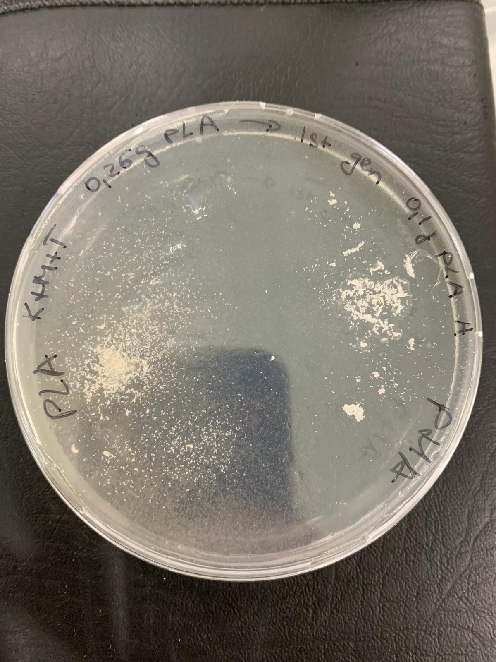

A.

B.

Figure 34 shows a plate where the left side is covered in PLA and the right side is covered in PHBV. A. The area indicated with the red circle shows that there is no growth on the side of the PLA. And the area indicated with the blue circle shows that there was growth on the side with the PHBV.

## Effects of freeze thaw on sample

The samples are expected to contain two different particles: plastic, microbes. In order to find/eliminate the microbes from our data the freeze thaw method was used. This has the effect of destroying the cells and thus reducing the amount of hits that might correspond to microbes. The effect of can be seen when you plot the sideward scatter against the forward scatter (figure 4).

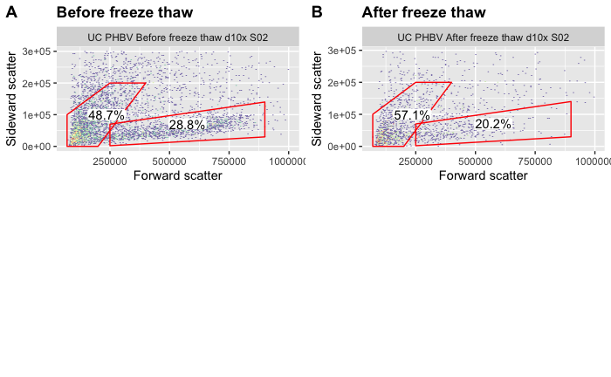

Figure 4 Shows the difference in the sample (A) before it was treated by the freeze thaw method and (B) after.

When looking at figure 4A two clearly different populations of particles can be observed, a stripe an a blob shown by the gates. After the being treated by the method a clear reduction in overall particles can be observed across the plot, and especially inside the location where the stipe had been previously. The percentage of particles inside the blob rose from 42.5% to 49.9% and inside the stripe the percentage of particles fell from 25.2% to 17.6%. These values were calculated using the formula below.

## Finding PHBV in flow cytometry

A large part of analyzing flow cytometry data is finding the cells or particles in which you are interested. In our data the key to determining the plastic and microbes to be in a comparison between the first fluorescence channel and the width of the particle. For some samples two clear hotspots are shown when plotted against each other (figure 5).

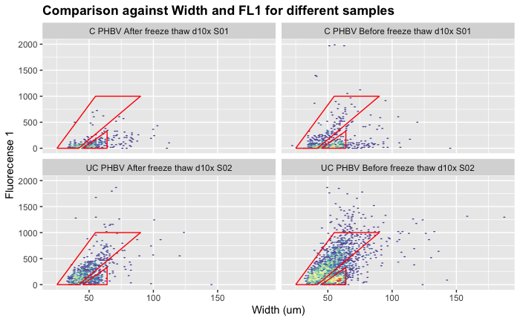

g2

g2

g2

g2

g1

g1

g1

g1

A

C

B

D

Figure 5 shows multiple samples with the first fluorescence channel plotted against the width. In figure A small green spots can be observed in both gates. These small green spots are can also be observed in figure B and C although more clearly and more separated. In figure D the two gates can be clearly separated as two different populations.

The two clusters are most clearly observed in sample UC PHBV before freeze thaw 2 where two different hotspots can be observed (figure 5D). This might indicate the presence of two different populations. Gate g1 is located for the Width at 25, 42, 90, 55 and for Fluorescence 1 at 0, 0, 1000, 1000. And gate g2 is located for the width at 45, 64, 64 and for Fluorescence 1 at 0, 0, 330.

When the datapoints in these gates two gates isolated and plotted with the sideward scatter against the forward scatter the two different populations are clearly separated (figure 6). With the g2 showing the particles that are suspected of being microbes (figure 6B) and the g1 showing the particles that are suspected of being the plastic particles (figure 6C). The interesting part is that using the same gate for another sample measured on another day shows the same results of splitting the two suspected groups. This makes a strong case for it being a useful gate for further analysis of the data.

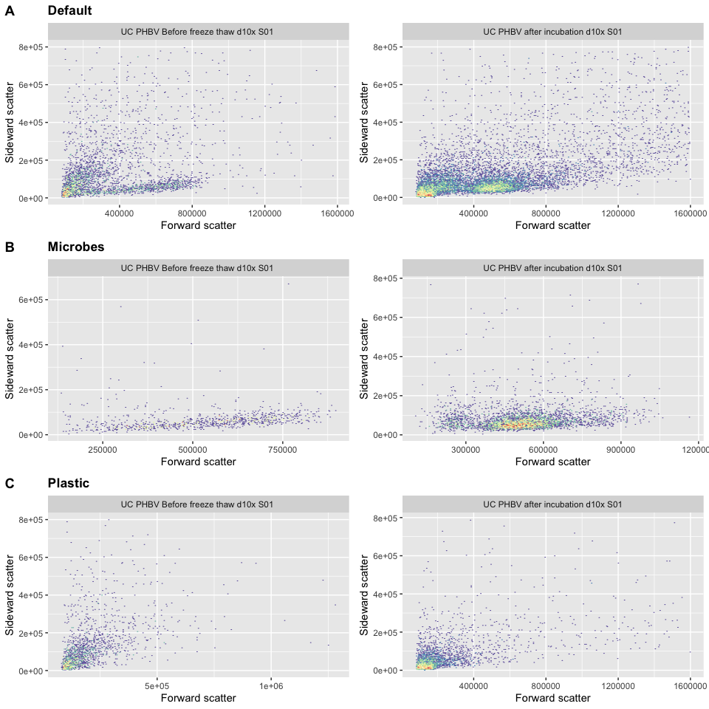

Figure 6 Shows the difference of the 2 gates found in figure 6. (A) Shows the forward and sideward scatter without the use of the gates. (B) Shows the particles that are inside the triangular shaped gate here labeled as microbes because of the tripe shown, previously suspected of being microbes. (C) Shows the particles that are inside the rectangular shaped gate here labeled as plastic.

## The effect of staining the PHBV

In order to see if staining the PHBV has an effect on the flow cytometry data two sets of samples were created one stained the other unstained. The staining should if any have an effect on the location of the peaks in the fluorescence channels of the flow cytometer. Density plots were created for each of the 4 fluorescence channels using the gate from the previous section that is suspected of being plastic to remove unwanted particles (figure 7). The differences in the first three fluorescence channels are clear, with the stained samples having a brighter emission. This can be seen in figure 7A where the peak changes from 50 to 600 when colored.

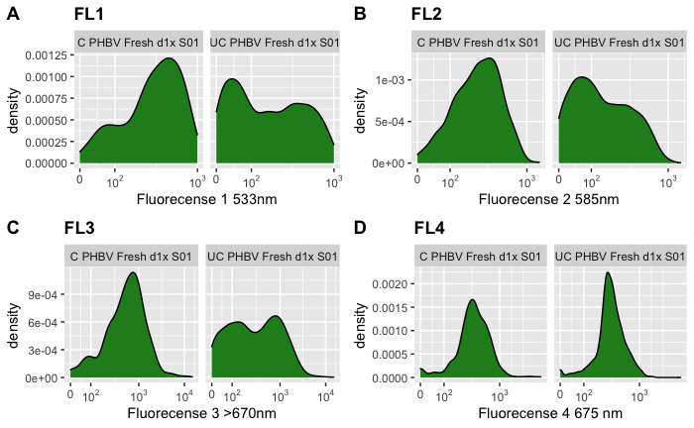

Figure 7 Shows density plots for each fluorescence channel. (A) The first fluorescence channel shows a large peak in the colored (left) at around 600 and the uncolored (right) shows a small peak around 45. (B) The second fluorescence channel shows a single peak in the colored sample (left) at around 500 and the uncolored (right) shows a small peak at around 60. (C) The third fluorescence channel shows again a large peak in the colored sample at around 800 whilst the uncolored sample shows a wide distribution of values. (D) The fourth fluorescence channel shows a wide peak at around 500 for the colored sample whilst the uncolored sample has thin peak around the same position.

# Conclusion and Discussion

The goal for this project was to find micro-organisms that can degrade PHBV and find a way to measure the degradation on a flow cytometer. Results from PHBV degradation from bacteria shows that the bacteria that were grown are capable of degrading the PHBV.

The freeze thaw method (FT) was used to eliminate microbial cell interference from the samples. To conclude if this has indeed been done, a plot was made comparing the sample before and after (figure 4). Figure 4a showed that before FT a large stripe is visible between FSC 250000 and 900000 which is mostly gone in after FT (figure 4b). This stripe is shown in figure 6b to be part of the section identified as microbes. This shows that FT has indeed destroyed most of the microorganisms in the samples. Although this method did succeed in destroying the cells in the sample, a possible problem arises if the debris from the cells are able to be measured by the FACS. It is possible that this debris can be on the same location as the PHBV, but more research needs to be done to be sure.

We also found that it is possible to measure PHBV and differentiate between the micro plastics and microorganisms. Finding that the fluorescence 1 against the width shows these two groups. With the gate for microbes being located at Width: 45, 64, 64 and fluorescence 1: 0, 0, 330. And the plastic gate being located at Width: 25, 42, 90, 55 and fluorescence 1: 0, 0, 1000, 1000. The location of the gate is constant across all of the different samples measured. This drop in observations seems to indicate that the particles in gate g2 are microorganisms.

Staining the plastic with oil red o has the effect of increasing the light output for most of the fluorescence channels with the exception being the 4th. Unfortunately, we were not able determine by how much the plastic has been degraded. This is mostly due to time constraints in analyzing the data, and the late discovery of the plastic gate. However, we still think that determining the plastic degradation using a flow cytometer is still possible, but more research is needed. A possible avenue for further research is looking closer at the shape of the plastic cloud with FSC and SSC over an amount of time and see if it changes.

# Reference

[1] Ibrahim, M. I., Alsafadi, D., Alamry, K. A., & Hussein, M. A. (2020). Properties and applications of poly(3-hydroxybutyrate-co-3-hydroxyvalerate) biocomposites. *Journal of Polymers and the Environment : Formerly: `Journal of Environmental Polymer Degradation'*, *29*(4), 1010–1030. <https://doi.org/10.1007/s10924-020-01946-x>

[2] Bonartsev, Anton & Boskhomodgiev, AP & Iordanskii, A. & Bonartseva, G.A. & Rebrov, AV & Makhina, T. & Myshkina, V. & Yakovlev, Sergey & Filatova, EA & Ivanov, EA & Bagrov, Dmitry & Zaikov, G.. (2012). Hydrolytic Degradation of Poly(3-hydroxybutyrate), Polylactide and their Derivatives: Kinetics, Crystallinity, and Surface Morphology. Molecular Crystals and Liquid Crystals - MOL CRYST LIQUID CRYST. 556. 288-300. 10.1080/15421406.2012.635982.

[3] Strauss, J.A., Shepherd, D.A., Macey, M. *et al.* Divergence exists in the subcellular distribution of intramuscular triglyceride in human skeletal muscle dependent on the choice of lipid dye. *Histochem Cell Biol* **154,**369–382 (2020). https://doi.org/10.1007/s00418-020-01898-2

# Appendix

Load the R packages

**library**(flowCore)

**library**(ggcyto)

**library**(ggpubr)

**Read the datasets into R**

data.raw.micha1 <- read.flowSet(path="PHBV_Micha1/", pattern=".fcs", alter.names = T)

data.raw.micha2<- read.flowSet(path="PHBV_Micha2/", pattern=".fcs", alter.names = T)

data.raw.micha3 <- read.flowSet(path="PHBV_Micha3/", pattern=".fcs", alter.names = T)

data.raw.micha4 <- read.flowSet(path="PHBV_Micha4/", pattern=".fcs", alter.names = T)

pData(data.raw.micha3)$well <- gsub("(.*).fcs", "\\1", sampleNames(data.raw.micha3))

Assign the correct sample names to dataset micha2

A.incubation <- rep("UC PHBV after incubation d10x S01", times=4)

sample_names <- c(A.incubation)

measurement_number <- c(1:4)

data.micha2 <- data.raw.micha2

pData(data.micha2)$sample <- sample_names

pData(data.micha2)$measurement <- measurement_number

pData(data.micha2)

Assign the correct sample names to dataset micha3

A.before <- rep("UC PHBV Before freeze thaw d10x S01 ", times=2)

A.after <- rep("UC PHBV After freeze thaw d10x S01", times=2)

B.before <- rep("UC PHBV Before freeze thaw d10x S02", times=2)

B.after <- rep("UC PHBV After freeze thaw d10x S02", times=2)

C.before <- rep("C PHBV Before freeze thaw d10x S01", times=2)

C.before2 <- rep("C PHBV Before freeze thaw d1x S01", times=1)

C.after <- rep("C PHBV After freeze thaw d10x S01", times=2)

C.after2 <- rep("C PHBV After freeze thaw d1x S01", times=2)

D.before <- rep("C PHBV Before freeze thaw d10x S02", times=2)

D.after <- rep("C PHBV After freeze thaw d10x S02", times=2)

D.after2 <- rep("C PHBV After freeze thaw d1x S02", times=2)

sample_names <- c(A.before, A.after, B.before, B.after, C.before, C.before2, C.after, C.after2, D.before, D.after, D.after2)

measurement_number <- c(rep(c(1,2), times=4), 1, rep(c(1,2), times=6))

data.micha3 <- data.raw.micha3[1:length(sample_names)]

pData(data.micha3)$sample <- sample_names

pData(data.micha3)$measurement <- measurement_number

pData(data.micha3)

Assign the correct sample names to dataset micha4

A.s1.100x.uc <- rep("UC PHBV Fresh d100x S01 ", times=2)

A.s1.100x.c <- rep("C PHBV Fresh d100x S01", times=2)

B.s1.10x.uc <- rep("UC PHBV Fresh d10x S01", times=2)

B.s1.10x.c <- rep("C PHBV Fresh d10x S01", times=2)

C.s2.100x.uc <- rep("UC PHBV Fresh d100x S02", times=2)

C.s2.100x.c <- rep("C PHBV Fresh d100x S02", times=2)

D.s2.10x.uc <- rep("UC PHBV Fresh d10x S02", times=2)

D.s2.10x.c <- rep("C PHBV Fresh d10x S02", times=2)

E.s1.1x.uc <- rep("UC PHBV Fresh d1x S01", times=2)

E.s1.1x.c <- rep("C PHBV Fresh d1x S01", times=2)

F.s1.1x.uc <- rep("UC PHBV Fresh d1x S02", times=2)

F.s1.1x.c <- rep("C PHBV Fresh d1x S02", times=2)

sample_names <- c(A.s1.100x.uc, A.s1.100x.c, B.s1.10x.uc, B.s1.10x.c, C.s2.100x.uc, C.s2.100x.c, D.s2.10x.uc, D.s2.10x.c, E.s1.1x.uc, E.s1.1x.c, F.s1.1x.uc, F.s1.1x.c)

measurement_number <- c(rep(c(1,2), times=12))

data.micha4 <- data.raw.micha4[1:length(sample_names)]

pData(data.micha4)$sample <- sample_names

pData(data.micha4)$measurement <- measurement_number

pData(data.micha4)

Create the gating set for dataset micha3 and add the found gates to it

gs.micha3 <- GatingSet(data.micha3)

# The zoom gate is to get a better look a better overview of the data.

g.zoom <- rectangleGate(filterId="zoom","FSC.A"=c(0, 1e6), "SSC.A"=c(0, 3e5))

gs_pop_add(gs.micha3, g.zoom)

# The zoom gates for the fluorescence channels are to get a better overview of the fluorescence data.

g.zoom.FL1 <- rectangleGate(filterId="zoom FL1","FL1.A"=c(-Inf, 2e3))

g.zoom.FL2 <- rectangleGate(filterId="zoom FL2","FL2.A"=c(-Inf, 2e3))

g.zoom.FL3 <- rectangleGate(filterId="zoom FL3","FL3.A"=c(-Inf, 4e3))

g.zoom.FL4 <- rectangleGate(filterId="zoom FL4","FL4.A"=c(-Inf, 4e3))

gs_pop_add(gs.micha3, g.zoom.FL1, parent="zoom")

gs_pop_add(gs.micha3, g.zoom.FL2, parent="zoom FL1")

gs_pop_add(gs.micha3, g.zoom.FL3, parent="zoom FL2")

gs_pop_add(gs.micha3, g.zoom.FL4, parent="zoom FL3")

# The microbes gate is created around a hotspot that is suspected to be microbes

g.microbes <- polygonGate(filterId = "microbes", "Width"=c(45, 64, 64), "FL1.A"=c(0, 0, 330))

# The plastics gate is created around a hotspot that is suspected to be plastics

g.plastics <- polygonGate(filterId = "plastics", "Width"=c(25, 42, 90, 55), "FL1.A"=c(0, 0, 1000, 1000))

gs_pop_add(gs.micha3, g.microbes, parent="zoom")

gs_pop_add(gs.micha3, g.plastics, parent="zoom")

# Gate p2 is another gate created around an area placed around a plastic area

g.p2 <- polygonGate(filterId = "p2", "FSC.A"=c(7e4, 2e5, 4e5, 2.5e5, 7e4), "SSC.A"=c(0, 0, 2e5, 2e5, 1e5))

gs_pop_add(gs.micha3, g.p2)

# These gates were assigned around peaks in the several density plots.

g.m1 <- rectangleGate(filterId="m1","FL1.A"=c(-Inf, 225))

g.m2 <- rectangleGate(filterId="m2","FL2.A"=c(-Inf, 200))

g.m3 <- rectangleGate(filterId="m3","FL3.A"=c( 1500, 2500))

g.m4 <- rectangleGate(filterId="m4","FL4.A"=c(5000, 7000))

g.m5 <- rectangleGate(filterId="m4","FL4.A"=c(300, 600))

gs_pop_add(gs.micha3, g.m1, parent="plastics")

# Recompute the gating set with the new gates

recompute(gs.micha3)

Create the gating set for dataset micha2 and add the found gate to it

gs.micha2 <- GatingSet(data.micha2)

# The zoom gate is to get a better look a better overview of the data.

g.zoom <- rectangleGate(filterId="zoom","FSC.A"=c(0, 1.6e6), "SSC.A"=c(0, 8e5))

gs_pop_add(gs.micha2, g.zoom)

# The zoom gates for the fluorescence channels are to get a better overview of the fluorescence data.

g.zoom.FL1 <- rectangleGate(filterId="zoom FL1","FL1.A"=c(-Inf, 2e3))

g.zoom.FL2 <- rectangleGate(filterId="zoom FL2","FL2.A"=c(-Inf, 2e3))

g.zoom.FL3 <- rectangleGate(filterId="zoom FL3","FL3.A"=c(-Inf, 2e4))

g.zoom.FL4 <- rectangleGate(filterId="zoom FL4","FL4.A"=c(-Inf, 2e4))

gs_pop_add(gs.micha2, g.zoom.FL1, parent="zoom")

gs_pop_add(gs.micha2, g.zoom.FL2, parent="zoom FL1")

gs_pop_add(gs.micha2, g.zoom.FL3, parent="zoom FL2")

gs_pop_add(gs.micha2, g.zoom.FL4, parent="zoom FL3")

# The variables g.microbes and g.plastics have the same values as in dataset micha3

gs_pop_add(gs.micha2, g.microbes, parent="zoom")

gs_pop_add(gs.micha2, g.plastics, parent="zoom")

# Recompute the gating set with the new gates

recompute(gs.micha2)

Create the gating set for dataset micha4 and add the found gate to it

gs.micha4 <- GatingSet(data.micha4)

# The zoom gate is to get a better look a better overview of the data.

g.zoom <- rectangleGate(filterId="zoom","FSC.A"=c(0, 1.6e6), "SSC.A"=c(0, 8e5))

gs_pop_add(gs.micha4, g.zoom)

# The variable g.plastics has the same values as in dataset micha3

gs_pop_add(gs.micha4, g.plastics, parent="zoom")

Plotting the forward scatter and sideward scatter without any gate selection

# Samples used in the plot

FACS_gate <- c(1,6)

# The gate showing the area used in later used for better view of the data

g.zoom <- rectangleGate(filterId="zoom","FSC.A"=c(0, 1e6), "SSC.A"=c(0, 3e5))

# Creating the plot using dataset micha3

ggcyto(gs.micha3[[FACS_gate]],aes(x=FSC.A,y=SSC.A),subset="root")+geom_hex(bins = 1000) + geom_gate(g.zoom) + facet_wrap(~sample,ncol = 2)

Analyzing the data from the freeze thaw method

# Gets the uncolored samples before freeze thaw from well B

FACS_gate <- grepl("(UC.*Before)", pData(data.micha3)$sample) & grepl("(B.*)", pData(data.micha3)$well)

# Gates that are suspected of being microbes and plastic

g.microbe <- polygonGate(filterId = "microbes","FSC.A"=c(2.5e5,2.5e5,9e5,9e5),"SSC.A"=c(2e3,7e4,14e4,3e4))

g.plastic <- polygonGate(filterId = " plastic ", "FSC.A"=c(7e4, 2e5, 4e5, 2.5e5, 7e4), "SSC.A"=c(0, 0, 2e5, 2e5, 1e5))

# Creates the plot containing the data from before freeze thaw

p.before <- as.ggplot(ggcyto(gs.micha3[[FACS_gate]],aes(x=FSC.A,y=SSC.A),subset="zoom")+geom_hex(bins = 150) + geom_gate(g.microbe) + geom_gate(g.plastic) + facet_wrap(~sample,ncol = 2) + ggtitle("Before freeze thaw") + xlab("Forward scatter") + ylab("Sideward scatter") + geom_stats()) *# check gate*

# Gets the uncolored samples after freeze thaw from well B

FACS_gate <- grepl("(UC.*After)", pData(data.micha3)$sample) & grepl("(B.*)", pData(data.micha3)$well)

# Creates the plot containing the data from after freeze thaw

p.after <- as.ggplot(ggcyto(gs.micha3[[FACS_gate]],aes(x=FSC.A,y=SSC.A),subset="zoom")+geom_hex(bins = 150) + geom_gate(g.microbe) + geom_gate(g.plastic) + facet_wrap(~sample,ncol = 2) + ggtitle("After freeze thaw") + xlab("Forward scatter") + ylab("Sideward scatter") + geom_stats()) *# check gate*

# Add the two plots together into one plot

ggarrange(p.before, p.after,

labels = c("A", "B"),

ncol = 2, nrow = 2)

Creating an array of comparison plot to identify interesting hotspots.

FACS_gate <- c(5, 7, 9, 12)

subset <- "zoom FL4"

p.FL1_FL2 <- as.ggplot(ggcyto(gs.micha3[[FACS_gate]],aes(x=FL1.A,y=FL2.A),subset=subset) + geom_hex(bins = 150) + facet_wrap(~sample,ncol = 2))

p.FL1_FL3 <- as.ggplot(ggcyto(gs.micha3[[FACS_gate]],aes(x=FL1.A,y=FL3.A),subset=subset) + geom_hex(bins = 150) + facet_wrap(~sample,ncol = 2))

p.FL1_FL4 <- as.ggplot(ggcyto(gs.micha3[[FACS_gate]],aes(x=FL1.A,y=FL4.A),subset=subset) + geom_hex(bins = 150) + facet_wrap(~sample,ncol = 2))

p.FL2_FL3 <- as.ggplot(ggcyto(gs.micha3[[FACS_gate]],aes(x=FL2.A,y=FL3.A),subset=subset) + geom_hex(bins = 150) + facet_wrap(~sample,ncol = 2))

p.FL2_FL4 <- as.ggplot(ggcyto(gs.micha3[[FACS_gate]],aes(x=FL2.A,y=FL4.A),subset=subset) + geom_hex(bins = 150) + facet_wrap(~sample,ncol = 2))

p.FL3_FL4 <- as.ggplot(ggcyto(gs.micha3[[FACS_gate]],aes(x=FL3.A,y=FL4.A),subset=subset) + geom_hex(bins = 150) + facet_wrap(~sample,ncol = 2))

p.FSC_FL1 <- as.ggplot(ggcyto(gs.micha3[[FACS_gate]],aes(x=FSC.A,y=FL1.A),subset=subset) + geom_hex(bins = 150) + facet_wrap(~sample,ncol = 2))

p.FSC_FL2 <- as.ggplot(ggcyto(gs.micha3[[FACS_gate]],aes(x=FSC.A,y=FL2.A),subset=subset) + geom_hex(bins = 150) + facet_wrap(~sample,ncol = 2))

p.FSC_FL3 <- as.ggplot(ggcyto(gs.micha3[[FACS_gate]],aes(x=FSC.A,y=FL3.A),subset=subset) + geom_hex(bins = 150) + facet_wrap(~sample,ncol = 2))

p.FSC_FL4 <- as.ggplot(ggcyto(gs.micha3[[FACS_gate]],aes(x=FSC.A,y=FL4.A),subset=subset) + geom_hex(bins = 150) + facet_wrap(~sample,ncol = 2))

p.SSC_FL1 <- as.ggplot(ggcyto(gs.micha3[[FACS_gate]],aes(x=SSC.A,y=FL1.A),subset=subset) + geom_hex(bins = 150) + facet_wrap(~sample,ncol = 2))

p.SSC_FL2 <- as.ggplot(ggcyto(gs.micha3[[FACS_gate]],aes(x=SSC.A,y=FL2.A),subset=subset) + geom_hex(bins = 150) + facet_wrap(~sample,ncol = 2))

p.SSC_FL3 <- as.ggplot(ggcyto(gs.micha3[[FACS_gate]],aes(x=SSC.A,y=FL3.A),subset=subset) + geom_hex(bins = 150) + facet_wrap(~sample,ncol = 2))

p.SSC_FL4 <- as.ggplot(ggcyto(gs.micha3[[FACS_gate]],aes(x=SSC.A,y=FL4.A),subset=subset) + geom_hex(bins = 150) + facet_wrap(~sample,ncol = 2))

g.something <- polygonGate(filterId = "something", "Width"=c(45, 64, 64), "FL1.A"=c(0, 0, 330))

g.something2 <- polygonGate(filterId = "something2", "Width"=c(25, 42, 90, 55), "FL1.A"=c(0, 0, 1000, 1000))

p.Width_FL1 <- as.ggplot(ggcyto(gs.micha3[[FACS_gate]],aes(x=Width,y=FL1.A),subset=subset) + geom_hex(bins = 100) + facet_wrap(~sample,ncol = 2) + geom_gate(g.something) + geom_gate(g.something2))

p.Width_FL2 <- as.ggplot(ggcyto(gs.micha3[[FACS_gate]],aes(x=Width,y=FL2.A),subset=subset) + geom_hex(bins = 100) + facet_wrap(~sample,ncol = 2))

p.Width_FL3 <- as.ggplot(ggcyto(gs.micha3[[FACS_gate]],aes(x=Width,y=FL3.A),subset=subset) + geom_hex(bins = 100) + facet_wrap(~sample,ncol = 2))

p.Width_FL4 <- as.ggplot(ggcyto(gs.micha3[[FACS_gate]],aes(x=Width,y=FL4.A),subset=subset) + geom_hex(bins = 100) + facet_wrap(~sample, ncol = 2))

p.Width <- ggcyto(gs.micha3[[FACS_gate]],aes(x=Width,),subset=subset) + geom_density(fill="forestgreen") + ggtitle("Width") + facet_wrap(~sample,ncol = 2)

p.FL1_FL2

The comparison plot of interest: Fluorescence 1 against Width

FACS_gate <- c(5, 7, 9, 12)

subset <- "zoom FL4"

g.microbes <- polygonGate(filterId = "microbes", "Width"=c(45, 64, 64), "FL1.A"=c(0, 0, 330))

g.plastics <- polygonGate(filterId = "plastics", "Width"=c(25, 42, 90, 55), "FL1.A"=c(0, 0, 1000, 1000))

p.Width_FL1 <- as.ggplot(ggcyto(gs.micha3[[FACS_gate]],aes(x=Width,y=FL1.A),subset=subset) + geom_hex(bins = 100) + facet_wrap(~sample,ncol = 2) + ggtitle("Comparison against Width and FL1 for different samples") + xlab("Width (um)") + ylab("Fluorecense 1") + geom_gate(g.microbes) + geom_gate(g.plastics))

p.Width_FL1

Identifying the effect of the gates ‘microbes’ and ‘plastics’

FACS_gate <- c(1)

g.r1 <- rectangleGate(filterId="r1", "FSC.A"=c(125000, 175000), "SSC.A"=c(0, 20000))

g.p1 <- polygonGate(filterId = "p1", "FSC.A"=c(1e5, 1.9e5, 1.8e5, 1.6e5, 1.4e5, 1e5), "SSC.A"=c(0, 5000, 3e4, 3e4, 2.5e4, 1e4))

p.clean <- as.ggplot(ggcyto(gs.micha3[[FACS_gate]],aes(x=FSC.A,y=SSC.A),subset="zoom") + geom_hex(bins = 200) + facet_wrap(~sample,ncol = 2) + ggtitle("Default") + xlab("Forward scatter") + ylab("Sideward scatter"))

p.clean.2 <- as.ggplot(ggcyto(gs.micha2[[FACS_gate]],aes(x=FSC.A,y=SSC.A),subset="zoom") + geom_hex(bins = 200) + facet_wrap(~sample,ncol = 2) + ggtitle("") + xlab("Forward scatter") + ylab("Sideward scatter"))

x <- ggarrange(p.clean, p.clean.2,

ncol = 2, nrow = 1)

p.microbe <- as.ggplot(ggcyto(gs.micha3[[FACS_gate]],aes(x=FSC.A,y=SSC.A),subset="microbes") + geom_hex(bins = 200) + facet_wrap(~sample,ncol = 2) + ggtitle("Microbes") + xlab("Forward scatter") + ylab("Sideward scatter") )

p.microbe.2 <- as.ggplot(ggcyto(gs.micha2[[FACS_gate]],aes(x=FSC.A,y=SSC.A),subset="microbes") + geom_hex(bins = 200) + facet_wrap(~sample,ncol = 2) + ggtitle("") + xlab("Forward scatter") + ylab("Sideward scatter") )

y <- ggarrange(p.microbe, p.microbe.2,

ncol = 2, nrow = 1)

p.plastic <- as.ggplot(ggcyto(gs.micha3[[FACS_gate]],aes(x=FSC.A,y=SSC.A),subset="plastics") + geom_hex(bins = 200) + facet_wrap(~sample,ncol = 2) + ggtitle("Plastic") + xlab("Forward scatter") + ylab("Sideward scatter") )

p.plastic.2 <- as.ggplot(ggcyto(gs.micha2[[FACS_gate]],aes(x=FSC.A,y=SSC.A),subset="plastics") + geom_hex(bins = 200) + facet_wrap(~sample,ncol = 2) + ggtitle("") + xlab("Forward scatter") + ylab("Sideward scatter") )

z <- ggarrange(p.plastic, p.plastic.2,

ncol = 2, nrow = 1)

ggarrange(x, y, z,

labels = c("A", "B", "C"),

ncol = 1, nrow = 3)

Compare the effects of staining the plastic with oil red o

FACS_subset<- "plastics"

FACS_gate <- grepl("E.*", pData(data.micha4)$well)

p.FL1 <- as.ggplot(ggcyto(gs.micha4[[FACS_gate]],aes(x=FL1.A,),subset=FACS_subset) + geom_density(fill="forestgreen") + scale_x_flowjo_biexp() + ggtitle("FL1") + facet_wrap(~sample ,ncol = 2) + xlab("Fluorecense 1 533nm"))

p.FL2 <- as.ggplot(ggcyto(gs.micha4[[FACS_gate]],aes(x=FL2.A,),subset=FACS_subset) + geom_density(fill="forestgreen") + scale_x_flowjo_biexp() + ggtitle("FL2") + facet_wrap(~sample,ncol = 2) + xlab("Fluorecense 2 585nm"))

p.FL3 <- as.ggplot(ggcyto(gs.micha4[[FACS_gate]],aes(x=FL3.A,),subset=FACS_subset) + geom_density(fill="forestgreen") + scale_x_flowjo_biexp() + ggtitle("FL3") + facet_wrap(~sample,ncol = 2) + xlab("Fluorecense 3 >670nm"))

p.FL4 <- as.ggplot(ggcyto(gs.micha4[[FACS_gate]],aes(x=FL4.A,),subset=FACS_subset) + geom_density(fill="forestgreen") + scale_x_flowjo_biexp() + ggtitle("FL4") + facet_wrap(~sample,ncol = 2) + xlab("Fluorecense 4 675 nm"))

ggarrange(p.FL1, p.FL2, p.FL3, p.FL4,

labels = c("A", "B", "C", "D"),

ncol = 2, nrow = 2)

Creating tables to get an overview of the data using median and mean values

*# The channels of interest*

channels <- c("Width", "FSC.A","SSC.A", "FL1.A", "FL2.A", "FL3.A", "FL4.A")

*# Wanted gate*

gate <- "plastics"

*# Get the data*

data.stats <- lapply(gs.micha3, **function**(x){gh_pop_get_data(x, gate)})

data.median <- lapply(data.stats, **function**(x){apply(x@exprs, 2, median)})

data.mean <- lapply(data.stats, **function**(x){apply(x@exprs, 2, mean)})

data.stats <- list("median"= data.median, "mean"=data.mean)

*# Cast list to a data frame and rotate it.*

data.stats.df <- lapply(data.stats, **function**(x){t(list2DF(x, nrow = length(x$A01.fcs)))})

*# Set the channel names as col names*

data.stats.df <- lapply(data.stats.df, **function**(x){colnames(x) <- names(data.median$A01.fcs); **return**(x)})

*# Make a comparison table of each wanted channel.*

comp.matrix <- lapply(data.stats.df, **function**(x){lapply(channels, **function**(y){outer(x[,y], x[,y], '-')})})

excluded_columns <- c(9, 14, 15, 20:26) *# Columns not needed*

isolate_columns <- rep(c(T,F), each=2, times=(ncol(comp.matrix[[1]][[1]])-7)/4) *# Only columns to be compared against*

*# Remove the unwanted columns and rows for the comparison*

comp.matrix.proc <- lapply(comp.matrix, **function**(x){lapply(x, **function**(y){ y[-excluded_columns,-excluded_columns][rev(isolate_columns) ,isolate_columns]})})

*# Isolate the wanted differences*

channel.stats.list <- lapply(comp.matrix.proc, **function**(x){lapply(x, **function**(y){vapply(1:ncol(y),FUN.VALUE = 1, FUN = **function**(z){value <- y[z,z];})})})

# Change the list to a dataframe

channel.stats <- lapply(channel.stats.list, **function**(x){list2DF(x, nrow = length(x[[1]]))})

# Set the column names to the channel names for mean and median

channel.stats <- lapply(channel.stats, **function**(x){colnames(x) <- channels; **return**(x)})

# Set the row names to the file names that are used to create the values

channel.stats <- lapply(channel.stats, **function**(x){row.names(x) <- vapply(1:ncol(comp.matrix.proc$median[[1]]),FUN.VALUE = "", FUN = **function**(y){paste(colnames(comp.matrix.proc$median[[1]])[y], "-", row.names(comp.matrix.proc$median[[1]])[y])});**return**(x)})

Showing the median table

knitr::kable(channel.stats$median, caption = "Diffrences in median values between samples for different measurement channels")

Showing the mean table

knitr::kable(channel.stats$mean, caption = "Diffrences in mean values between samples for different measurement channels")